Usando vb script no script task

Precompilescript = false
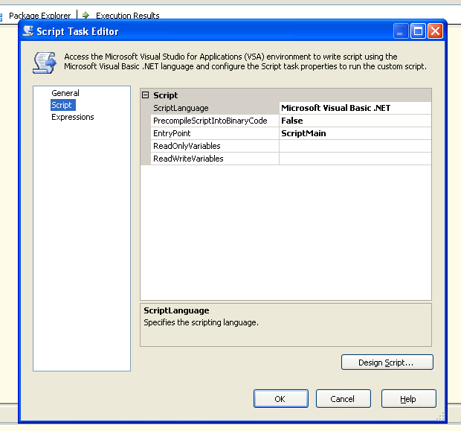

' Microsoft SQL Server Integration Services Script Task
' Write scripts using Microsoft Visual Basic
' The ScriptMain class is the entry point of the Script Task.
Option Strict Off
Imports System
Imports System.Data
Imports System.Math
Imports Microsoft.SqlServer.Dts.Runtime

Public Class ScriptMain

' The execution engine calls this method when the task executes.
' To access the object model, use the Dts object. Connections, variables, events,
' and logging features are available as static members of the Dts class.
' Before returning from this method, set the value of Dts.TaskResult to indicate success or failure.
'
' To open Code and Text Editor Help, press F1.
' To open Object Browser, press Ctrl+Alt+J.

Public Sub Main()
'
' Add your code here
'
Dim excel As Object
Dim book As Object

excel = CreateObject("Excel.Application")
excel.workbooks.open("C:\teste.xls")
excel.sheets("plan1").range("a1").value = 1
excel.run("celulab")
excel.workbooks(1).save()
excel.workbooks.close()
excel = Nothing

Dts.TaskResult = Dts.Results.Success
End Sub

End Class

